assignment clo-1 fe sw

RAAZIA IMRAN SE-24009 SECTION-A 05/05/2025
PH-122 APPLIED PHYSICS

Question 1: Discuss the difference between Diamagnetism, Para-magnetism and Ferromagnetism and the effect of temperature on magnetization 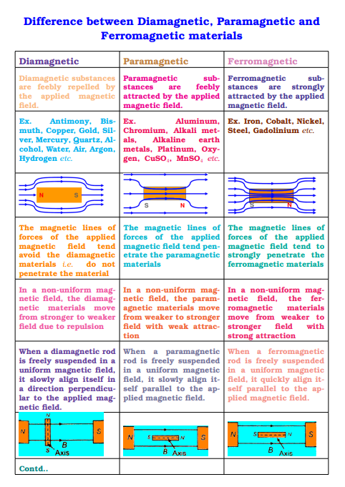
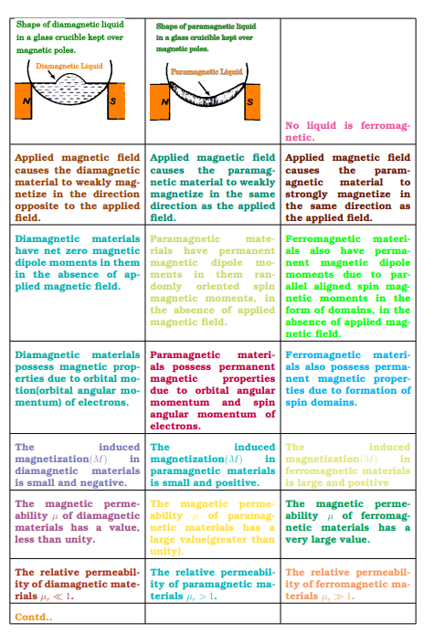
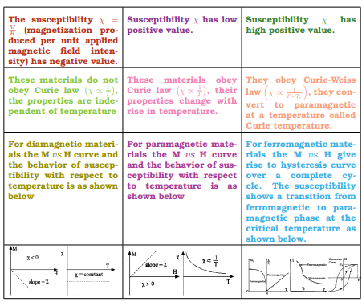

EFFECT OF TEMPERATURE ON MAGNETIZATION :-
• In paramagnetic materials, increasing the temperature increases the random thermal motion, which disturbs the alignment of magnetic moments, thereby reducing the net magnetization.
• In ferromagnetic materials, temperature plays a crucial role. As temperature increases, thermal agitation disrupts the alignment of domains. Above a certain critical temperature called the Curie Temperature, the ferromagnetic material loses its spontaneous magnetization and becomes paramagnetic.
• In diamagnetic materials, since the effect is not related to alignment of magnetic moments but rather induced currents, temperature has negligible effect.

Question 2: Compare the behavior of conductor and insulator in an electric field.
a) Conductors
Conductors are materials that allow the free movement of electric charges, particularly electrons. When a conductor is placed in an external electric field, the free electrons inside it immediately start to move in response to the field. These electrons continue to move until they have rearranged themselves in such a way that they cancel the internal electric field. As a result, in electrostatic equilibrium, the net electric field inside a conductor is zero. Furthermore, excess electric charges in a conductor reside only on its outer surface, and the electric field just outside the surface is perpendicular to the surface. Conductors are essential in applications such as electrical wiring and shielding, where quick redistribution of charge is needed.
b) Insulators (Dielectrics)
Insulators, or dielectrics, are materials that do not have free charges available to move. The electrons in an insulator are tightly bound to atoms or molecules. When an insulator is placed in an electric field, the atomic charges do not move freely, but a small displacement of the positive and negative charges occurs, leading to polarization of the material. This polarization results in a reduced effective electric field within the material compared to the external field. Unlike conductors, insulators do not cancel the electric field inside them; rather, they allow it to penetrate, but to a lesser extent. This property is utilized in capacitors, where a dielectric material increases the capacitance by reducing the field strength between plates.

Question 3: As the projectile moves in its path is there any point along the path where the velocity and acceleration are (a) perpendicular to each other. (b) parallel to each other.

Projectile Motion: Relationship Between Velocity and Acceleration

(a) When are velocity and acceleration perpendicular:
At the highest point of the projectile’s path, the object is momentarily not moving upward or downward — its vertical velocity becomes zero. However, it still continues to move horizontally, so it has a horizontal velocity. At the same point, the acceleration due to gravity is still acting vertically downward. Since one vector (velocity) is horizontal and the other (acceleration) is vertical, they are at right angles (90°) to each other. So yes, there is a point — at the top of the path — where velocity and acceleration are perpendicular.

(b) When are velocity and acceleration parallel:
Velocity and acceleration are parallel when they point in the same direction. This happens during the downward motion of the projectile — that is, after the highest point, when the object is falling. In this case, the velocity is downward (since the object is moving down), and the acceleration is also downward (due to gravity), so both are in the same direction. Hence, they are parallel during the downward motion.
Similarly, during the upward motion, the velocity is upward while the acceleration is downward, so they are in opposite directions. In this case, we say they are anti-parallel, not parallel.
Question 4: Discuss the damped harmonic oscillation and its types.

The Damped Harmonic Oscillator

A damped oscillation refers to an oscillation that degrades over a specific period of time. Common examples of this include a weight on a spring, a swinging pendulum. The damped harmonic oscillator is a typical issue in the field of mechanics. Moreover, it defines the movement of mechanical oscillators, such as a spring pendulum, which are under the influence of both friction and a restoring force.

In the fields of electronics and mechanics, virtually all physical systems are subject to resistance or friction. These considerations include IMF (intermolecular forces), friction, as well as air resistance.
The need for assessing damping is critical in all oscillatory systems. In a real-world scenario, oscillators are susceptible to friction, or damping, which decelerates the motion of the system. Due to this frictional force, the velocity decreases in proportion to the functioning frictional force. Moreover, in a simplified undriven harmonic oscillator, the only force affecting the mass is the restoring force. However, in damped harmonic oscillators, there is an additional frictional force that is always acting in opposition to the motion.

Damped Harmonic Motion Calculations
In reference to vibrating systems, we model the Ff (frictional force) proportionately to the v (velocity) of the object:
Ff = −cv
Here, c is called the viscous damping coefficient.
We express the balance of forces, or Newton's second law of motion, for damped harmonic oscillators as follows:
F = -kx -c = m(d²x/dt²)
We express the undamped angular frequency of the oscillator as:
ω₀ = √k/m
We express the damping ratio as:
ζ = c/(2√mk)
As stated earlier, an oscillator is a circuit or device that has a periodic rhythmic response, whereas a damped oscillation refers to an oscillation that degrades over time. Keep in mind that the value of the damping ratio ζ vitally determines the behavior of the oscillatory system. Therefore, a damped harmonic oscillator is subdivided into three distinct categories:
Overdamped (ζ > 1): Where the system returns to a steady state without oscillating.
Critically damped (ζ = 1): When the system returns to a steady state as quickly as possible without oscillating. This can also lead to issues called overshoot. However, this is an acceptable occurrence for the damping of specific system applications.
Underdamped (ζ < 1): This is when a system oscillates at a frequency marginally different than the undamped case, and the amplitude decreases to zero gradually.
Another parameter to consider in oscillatory systems is the Q factor (quality factor). In the area of engineering and physics, the Q factor is a dimensionless parameter that quantifies the severity in which a resonator or oscillator is underdamped. In summary, we define it as the ratio of the peak energy stored within an oscillation cycle to the energy lost per radian of the cycle. The formula is as follows:
Q = 2π × (energy stored)/(energy lost per cycle)
Since nearly all systems in the field of mechanics, physics, and electronics are subject to friction and resistance, it is critical that we assess the degree of this degradation accurately. A firm understanding of how these forces affect functionality is vital to the overall design process.
Types of Damped Harmonic Oscillations
Damped oscillations are usually divided into three types based on how quickly the object comes to rest:
1. Under-Damped Oscillation
In an under-damped system, the object continues to oscillate (move back and forth), but each time the movement is weaker than before. The amplitude decreases slowly over time, but the object takes a while before stopping completely. This is the most common type of damping seen in everyday life. A good example is a pendulum that swings and gradually comes to a stop.

2. Critically Damped Oscillation
In a critically damped system, the object returns to its resting position very quickly without oscillating at all. It is the fastest possible return to rest without any backand-forth motion. This type of damping is very useful in machines and systems where we want to avoid vibration and stop motion smoothly and quickly. For example, car shock absorbers are designed to be critically damped so that the car doesn’t bounce after hitting a bump.
3. Over-Damped Oscillation
In over-damped systems, the object also does not oscillate, but it returns to its resting position very slowly. It takes longer to stop compared to a critically damped system. This happens when the damping force is too strong, and the system is heavily resisted. An example could be a door closer that shuts the door very slowly without bouncing

